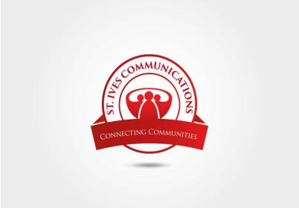

Role: Project Manager

Organisation: St. Ives Communications

Reports to: Director of Project

We seek to appoint a female project manager who is passionate about womens rights, economic growth and social progress.

Location: Lagos-Ibadan Expressway

Contract: 3 years

**Job Description**

* Responsible for the development and execution of project deliverables from concept note to implementation. Lead on project planning, budgeting, action plans and monitoring processes.
* Strategic planning, monitoring and evaluating outcomes with attention to concrete objectives.
* Ensure project activities comply with the policies and regulations of donor organisations. Responsible for submitting activity reports and financial reports on regular basis to the donor.
* Monitor project activities and project expenditure. Oversee the preparation and submission of annual activity-based project budgets as well as monthly and quarterly financial reports.
* Lead, manage and motivate the project team to remain optimistic even when faced with challenges. Encourage good performance and values. Coordinate work with consultants and volunteers.
* Ensures that project expenditure remains within budgetary line items and according to contractual agreements. Management of the project budget and approval of requisitions, advances and expenses. Preparation of costed work plans and submission of timely funds requests.
* Provision of technical and programmatic leadership to ensure the quality implementation of project activities and achievement of objectives. Provide management support, supervision and direction for the implementation of the Project.
* Plan and coordinate the development of Annual Work-plans, all reports and individual work-plans, adhering to the project proposal objectives with support from supervisor.
* Produce monthly, interim and final narrative that meet the requirements of the donor. Ensures all records are maintained and regularly updated.
* Ensuring  community participation and cooperation of partners.Attend Government, partners and NGO meetings and ensure cross agency collaboration. Enlist the cooperation and assistance of Government departments and NGOs where and when required, to ensure achievement of project objectives.
* Ensures close collaboration and coordination with partners and donors to guarantee smooth implementation of activities and achievement of results as specified in grant agreements.
* Employs resourcefulness in project design, implementation and monitoring. Trouble shoots project problems. Identifies and implements creative solutions.
* Ensures that all implemented activities are relevant to the mission and vision of the organization.
* Identify and carry out fundraising strategies and efforts that complement

**QUALIFICATIONS & SKILLS**

* A degree in business-related, management fields.
* Interest and experience in community development especially in working withWomen.
* At least 5 years experience in project management.
* Excellent verbal and written communicator with good presentation and organisational skills.
* Proficient in Word, PowerPoint, Outlook and Excel.
* Good team player.

**APPLY TO: Qualified candidates should send their resumes to [hr@voiceofwomen.ng](mailto:voiceofwomen917@gmail.com) on or before 6.pm on Friday April 25, 2022. The email subject should read “Project Manager, Application’**